Analyzing the Effects of Altered Tor Traffic on Onion Service Classification using Machine Learning
A Project Report
Submitted to the Faculty of Engineering of
JAWAHARLAL NEHRU TECHNOLOGICAL UNIVERSITY KAKINADA, KAKINADA
In partial fulfillment of the requirements for the award of the Degree of
BACHELOR OF TECHNOLOGY
In
COMPUTER SCIENCE AND ENGINEERING
By
CH. YAMINI NAGA SAI PRASANNA (21481A0549)
A. MAHITH SAI REDDY (21481A0510)
B.BHARATH (21481A0516)
B. SMILY (21481A0515)
Under the guidance of
P.RAJESH , M.Tech

Assistant Professor of CSE Department
DEPARTMENT OF COMPUTER SCIENCE AND ENGINEERING SESHADRI RAO GUDLAVALLERU ENGINEERING COLLEGE
(An Autonomous Institute with Permanent Affiliation to JNTUK, Kakinada)
SESHADRI RAO KNOWLEDGE VILLAGE
GUDLAVALLERU – 521356
ANDHRA PRADESH
2025-2026

SESHADRI RAO GUDLAVALLERU ENGINEERING COLLEGE
(An Autonomous Institute with Permanent Affiliation to JNTUK, Kakinada) SESHADRI RAO KNOWLEDGE VILLAGE, GUDLAVALLERU


DEPARTMENT OF COMPUTER SCIENCE AND ENGINEERING

CERTIFICATE
This is to certify that the project report entitled “Analyzing the Effects of Altered Tor Traffic on Onion Service Classification using Machine Learning” is a bonafide record of work carried out by Ch.Yamini Naga Sai Prasanna(21481A0549) A.Mahith Sai Reddy(21481A0510) B.Bharath(21481A0516) B. Smily(21481A0515) under the guidance and supervision in the partial fulfillment of the requirements for the award of the degree of Bachelor of Technology in Computer Science and Engineering of Jawaharlal Nehru Technological University Kakinada, Kakinada during the academic year 2024-25.

Project Guide Head of the Department
(P. RAJESH) (Dr. M. BABU RAO)

External Examiner

ACKNOWLEDGEMENT

The satisfaction that accompanies the successful completion of any task would be incomplete without the mention of people who made it possible and whose constant guidance and encouragements crown all the efforts with success.
We would like to express our deep sense of gratitude and sincere thanks to Dr.N.Siva Chintaiah, Assistant Professor, Department of Computer Science and Engineering for his constant guidance, supervision and motivation in completing the project work.
We feel elated to express our floral gratitude and sincere thanks to Dr. M. Babu Rao, Head of the Department, Computer Science and Engineering for his encouragements all the way during analysis of the project. His annotations, insinuations and criticisms are the key behind the successful completion of the project work.
We would like to take this opportunity to thank our beloved principal Dr. Burra Karuna Kumar for providing a great support for us in completing our project and giving us the opportunity for doing project.
Our Special thanks to the faculty of our department and programmers of our computer lab. Finally, we thank our family members, non-teaching staff and our friends, who had directly or indirectly helped and supported us in completing our project in time.

Team members
Ch. Yamini (21481A0549)
A.Mahith Sai Reddy (21481A0510)
B. Bharath (21481A0516)
B.Smily (21481A0515)
INDEX
Title Page No
LIST OF ABBREVATIONS i
LIST OF FIGURES i
ABSTRACT ii
CHAPTER 1:INTRODUCTION 1-5
CHAPTER 2: FEASIBILITY STUDY 6-7
CHAPTER 3: LITERATURE SURVEY 8-9
CHAPTER 4: SYSTEM ANALYSIS 10-12
CHAPTER5: SYSTEM DESIGN 13-19
CHAPTER6: IMLIMENTATION 20-21
CHAPTER7:SOFTWARE ENVIRONMENT 22-31
CHAPTER8: SYSTEM TESTING 32-34
CHAPTER9:RESULT AND DISCUSSION 35-42

CHAPTER10: CONCLUSION 43
CHAPTER11: BIOGRAHY (references) 44-45

LIST OF ABBREVATIONS

Abbreviation | Explanation
CNN | Convolutional Neural Networks
ResNet | Residual Networks
OS | Onion Service
SVM | Support vector Machine
RNN | Recurrent Neural Network
9KNN | K-Nearest Neighbours
Tor | The Onion Router

LIST OF FIGURES
Figure No. | Description | Page No.
Fig 5.1.1 | System Architecture | 13
Fig 5.1.2 | Machine Learning Workflow for Onion Service Classification | 13
Fig 5.2.1 | Use Case Diagram for Onion Service Classification | 15
Fig 5.2.2 | Class Diagram for Onion Service Classification System | 16
Fig 5.2.3 | Activity Diagram for Onion Service Classification System | 17
Fig 5.2.4 | Component Diagram for Onion Service Classification System | 18
Fig 5.2.5 | Deployment Diagram for Onion Service Classification System | 19

i
ABSTRACT
Classifying network traffic is important for traffic shaping and monitoring. In the last two decades,with the emergence of privacy concerns, the importance of privacy-preserving technologies has risen. The Tor network, which provides anonymity to its users and supports anonymous services known as Onion Services, is a popular way to achieve online anonymity. However, this anonymity (especially with Onion Services) is frequently misused, encouraging governments and law enforcement agencies to de-anonymise them.Therefore, in this paper, we try to identify the classifiability of Onion Service traffic, focusing on three main contributions. First,we try to identify Onion Service traffic from other Tor traffic. The techniques we have used can identify Onion Service traffic with >99% accuracy.However, there are several modifications that can be done to the Tor traffic to obfuscate its information leakage. In our second contribution, we evaluate how our techniques perform when such modifications have been done to the Tor traffic.Our experimental results show that the seconditions make the Onion Service traffic less distinguishable (in some cases, the accuracy drops by more than 15%.) In our final contribution, we identify the most influential feature combinations for our classification problem and evaluate their impact.

ii

1.INTRODUCTION
1.1 Introduction
Tor [1] is ananonymity network that hides the identity of its users by routing the traffic through multiple intermediary nodes. Tor also supports the provision of anonymous services known as Onion Services (also known as hidden services) with onion as the top-level domain name. Tor’s ability to act as a censorship circumvention tool has encouraged security experts, network defenders, and law enforcement agencies to identify Tor traffic from other encrypted and non-encrypted traffic[2],[3]. For example, [3],[4] tried to classify Tor traffic from non-Tor Traffic ,[2],[5] tried to classify the application types in Tor traffic, and[6] tried to classify Tor traffic from other anonymity network traffic such as I2P traffic and Web mix Traffic. However, in this work, we intend to explore the distinguishability of Onion Service traffic from standard Tor traffic using traffic analysis. We formulate three research questions to act as a foundation for our work.Second, we try to investigate the same problem under different settings. Specifically, we try to investigate RQ2: How do our results for RQ1 hold when we use modified Tor traffic? There are certain techniques that can be implemented in Tor to change its traffic patterns. Introducing padding [10], using dummy bursts and delays [11], and splitting the traffic [12] are a few examples of such techniques. These techniques1 have been developed with the intention of obfuscating the information leakage of Tor traffic. The main importance of answering RQ2 is that we can confirm whether our findings from RQ1 will hold true as and when such modifications are introduced to the Tor traffic. If we are able to still distinguish Onion Service traffic, it is an indication that these modifications are not effective in masking Onion Service traffic, if they are realised in the future. If the modifi cations do affect the Onion Service classifiability, it opens up questions about the validity of prior works, such as [3] and [6] in a setting with those modifications implemented. In order to investigate RQ1 and RQ2, we employ passive network analysis, in which we utilise traces of network traffic captured at points between the client and the Tor entry node. We first extract fifty features from each traffic trace, which creates a unique fingerprint of that trace. A traffic trace refers to a set of consecutive packets transmitted between the client and the entry node in a given duration.

1.2 OBJECTIVE
The primary objective of this study is to investigate the classification of Tor network traffic— specifically, Onion Service traffic—and assess how modifications to Tor traffic impact the ability to classify Onion Services accurately. The specific goals are:
- Onion Service Traffic Classification: To develop and evaluate techniques for accurately classifying Onion Service traffic from other Tor traffic with greater than 99% accuracy.
- Impact of Traffic Modifications: To explore how modifications made to Tor traffic (designed to obfuscate traffic and enhance anonymity) affect the performance of Onion Service traffic classification. This includes evaluating the decrease in accuracy due to such modifications.
- Feature Evaluation: To identify and analyze the most influential feature combinations that contribute to the classification of Onion Service traffic and assess their impact on classification performance, especially when traffic obfuscation techniques are applied.
- Improvement of Traffic Classification Techniques: To provide insights into improving traffic classification techniques in scenarios where Tor traffic is modified to evade detection and classification.

  - PROBLEM STATEMENT
The use of Tor as a privacy-preserving technology allows users to maintain anonymity while browsing the internet or accessing anonymous services, known as Onion Services. While Tor offers a significant degree of privacy, it has also become a popular tool for users engaged in illicit activities, prompting governments and law enforcement agencies to develop methods to de-anonymize Tor users and monitor Onion Service traffic.
One of the key challenges in classifying Tor traffic, especially Onion Service traffic, is distinguishing it from regular Tor traffic and other types of network traffic. Although recent methods have shown promising results in identifying Onion Service traffic with high accuracy (over 99%), there is a significant problem when it comes to obfuscation techniques that modify Tor traffic to mask its characteristics and make it harder to classify.
As the Tor network evolves, various modifications (such as traffic padding, timing obfuscation, and packet size adjustments) can be applied to Tor traffic, which may reduce the distinguishability between Onion Services and regular Tor traffic. These modifications pose a significant challenge to existing classification models, leading to a decrease in classification accuracy

  - SOFTWARE REQUIREMENTS
To operate a program smoothly, certain hardware and software must be in place, and this is known as the software requirements. These prerequisites typically aren't part of the application installation package and need to be installed separately.
Platform - A platform is a foundational piece of hardware or software that allows software to execute on a computer. Computer hardware, software, languages, and runtime libraries are all examples of common platforms. Operating systems are among the most fundamental components of any computer. While it's possible for software to incompatibly with later versions of the same OS, backward compatibility is typically preserved. Although it is not necessarily the case, most Windows XP software will not run on Windows 98. Linux versions employing Kernel v2.2 or v2.4 are rarely compatible with software developed using later Linux Kernel v2.6 capabilities.
APIs and drivers – Newer drivers or an API are required by software that makes advantage of high-end display devices. Media-related tasks, especially game development, are handled by Microsoft's DirectX suite of application programming interfaces.
Web browser - The default browser is utilized by the majority of web apps and software that is dependent on Internet technologies. Microsoft Internet Explorer is widely used by Windows users and makes use of ActiveX components, which are not without their risks.
- Software : Anaconda
- Primary Language : Python
- Frontend Framework : Flask
- Back-end Framework : Jupyter Notebook
- Database : Sqlite3
- Front-End Technologies : HTML,CSS,JavaScript and Bootstrap

1.5 HARDWARE REQUIREMENTS
Hardware, sometimes known as a computer's physical resources, is the most typical collection of requirements provided by an OS or software program. A hardware compatibility list (HCL) is a part of many operating systems that accompany a hardware requirements list (HRL). An HCL is a catalogue of known compatible and, at times, incompatible hardware components for a certain program or operating system. What follows is an analysis of the hardware specifications in further detail.
Computer network architecture — every operating system is specifically designed to work on a certain kind of machine. The ideal operating system and hardware configuration for a lot of apps is carefully considered before development begins. There are platforms that can do this, but most applications and operating systems still need to be recompiled in order to work on these platforms. Here is a rundown of some of the most widely used OSes and the underlying architectures that power them.
Processing power—an essential system requirement for any program is the processing capacity of the central processing unit (CPU). The x86 architecture's software often takes the CPU type and clock speed into account when estimating processing capabilities. A lot of other power and performance-affecting CPU characteristics, such as bus speed, cache, and MIPS, are ignored. For instance, the throughput speeds may vary greatly amongst CPUs of the same manufacturer, even when their clock rates are identical. This indicates that this concept of power is often incorrect. The widespread usage of Intel Pentium CPUs makes them frequent class discussions topics.
While programs are active, all of the data stored by a computer is accessed from random access memory (RAM). Calculating the memory utilisation of an application, together with its connected operating system, files, and supporting apps, requires careful consideration of all these processes. The optimal performance of unrelated programs is critical on a multi-tasking computer system, which we kept in mind while creating this criteria.

Many factors influence how much more space a hard disc needs. Think about how big the application is, how many temporary files are created and stored when the software is installed or used, and how likely it is that you will need to use swap space if your RAM isn't enough.
A high-end display adapter is often listed as a system requirement in programs that need a better-than-average computer graphics display, including graphics editors and high-end games.
Some peripherals are used extensively by certain software packages, which calls for their improved functionality or performance. A few other examples of peripherals include optical drives, mouse, keyboards, network adapters, and pointing devices.
1) Operating System : Windows Only
2) Processor : i5 and above
3) Ram : 8gb and above
4) Hard Disk : 25 GB in local drive

2. FEASIBILITY STUDY

Feasibility Study
This section provides a business proposal outlining the project's general outline and estimated costs after assessing the project's viability. During system analysis, the feasibility of the proposed system is examined. In this way, we know the proposed remedy won't put undue strain on the business. The first step in doing a feasibility study is to identify the most important requirements of the system.
Three key considerations involved in the feasibility analysis are
  - ECONOMICAL FEASIBILITY
  - TECHNICAL FEASIBILITY
  - SOCIAL FEASIBILITY
2.1 ECONOMICAL FEASIBILITY
This study delves into the system's impact on the organization's finances. Funds for system research and development are limited at the company. Every dollar must have a purpose. Since most of the technologies used are free, the built system stayed within budget. Make sure to only buy individualized products.

2.2 TECHNICAL FEASIBILITY
This study evaluates the technological feasibility, or the requirements of the system. To avoid wasting technical resources, no system should be constructed. Our technological resources will be put to the test. Customers can anticipate lofty standards. Due to the low or nonexistent modification requirements, the current system can only have a minor need.

2.3 SOCIAL FEASIBILITY
Researchers examine how users feel about the system. It also includes training people to make the most of the technology. Everyone needs to see the system for what it is: a necessary evil. The only thing that matters for users to accept the system is how it is presented to them. Being the system's end user, he needs to feel comfortable enough to provide helpful feedback.

3.LITERATURE SURVEY

LITERATURE SURVEY
[1] R. Dingledine, N. Mathewson, and P. Syverson, “Tor: The Second Generation Onion Router,” in Proceedings of the 13th USENIX Security Symposium, SSYM’04, (San Diego, CA, USA), pp. 303–320, August 2004.
We present Tor, a circuit-based low-latency anonymous communication service. This second-generation Onion Routing system addresses limitations in the original design by adding perfect forward secrecy, congestion control, directory servers, integrity checking, configurable exit policies, and a practical design for location-hidden services via rendezvous points. Tor works on the real-world Internet, requires no special privileges or kernel modifications, requires little synchronization or coordination between nodes, and provides a reasonable tradeoff between anonymity, usability, and efficiency. We briefly describe our experiences with an international network of more than 30 nodes. We close with a list of open problems in anonymous communication.
[2] M. AlSabah, K. Bauer, and I. Goldberg, “Enhancing Tor’s Performance Using Real-Time Traffic Classification,” in Proceedings of the 2012 ACM Conference on Computer and Communications Security, CCS ’12, (New York, NY, USA), pp. 73–84, October 2012.
Tor is a low-latency anonymity-preserving network that enables its users to protect their privacy online. It consists of volunteer-operated routers from all around the world that serve hundreds of thousands of users every day. Due to congestion and a low relay-to-client ratio, Tor suffers from performance issues that can potentially discourage its wider adoption, and result in an overall weaker anonymity to all users.
We seek to improve the performance of Tor by defining different classes of service for its traffic. We recognize that although the majority of Tor traffic is interactive web browsing, a relatively small amount of bulk downloading consumes an unfair amount of Tor's scarce bandwidth.

Furthermore, these traffic classes have different time and bandwidth constraints; therefore, they should not be given the same Quality of Service (QoS), which Tor offers them today.
We propose and evaluate DiffTor, a machine-learning-based approach that classifies Tor's encrypted circuits by application in real time and subsequently assigns distinct classes of service to each application. Our experiments confirm that we are able to classify circuits we generated on the live Tor network with an extremely high accuracy that exceeds 95%. We show that our real-time classification in combination with QoS can considerably improve the experience of Tor clients, as our simple techniques result in a 75% improvement in responsiveness and an 86% reduction in download times at the median for interactive users.
[3] A. H. Lashkari., G. D. Gil., M. S. I. Mamun., and A. A. Ghorbani., “Char acterization of Tor Traffic using Time based Features,” in Proceedings of the 3rd International Conference on Information Systems Security and Privacy, ICISSP 2017, (Porto, Portugal), pp. 253–262, February 2017.
Traffic classification has been the topic of many research efforts, but the quick evolution of Internet services and the pervasive use of encryption makes it an open challenge. Encryption is essential in protecting the privacy of Internet users, a key technology used in the different privacy enhancing tools that have appeared in the recent years. Tor is one of the most popular of them, it decouples the sender from the receiver by encrypting the traffic between them, and routing it through a distributed network of servers. In this paper, we present a time analysis on Tor traffic flows, captured between the client and the entry node. We define two scenarios, one to detect Tor traffic flows and the other to detect the application type: Browsing, Chat, Streaming, Mail, Voip, P2P or File Transfer. In addition, with this paper we publish the Tor labelled dataset we generated and used to test our classifiers.

4. SYSTEM ANALYSIS
4.1 EXISTING SYSTEM:
ADABOOST extends the traditional system, achieving high accuracy in classifying Tor and Onion services, demonstrating superior performance compared to traditional methods, and improving classification accuracy.

Disadvantages:
- Existing system may lack perfect accuracy for Tor and Onion service classification.
- May not handle large volumes of network traffic effectively.
- Challenging to adapt to changing network patterns.
- May overlook ethical and privacy considerations.
- Reporting may lack detailed insights for informed decisions.

4.2 PROPOSED SYSTEM:

The proposed work introduces two improved channel attention modules: a space-time (ST) interaction module, which captures detailed spatiotemporal features through matrix operations, and a depth wise separable convolution module, which processes spatial and channel information independently for more refined feature extraction. This model uses a multi-scale CNN designed to handle sequential data, applying low-rank learning to each data segment and connecting them along the time axis to form a cohesive activity representation. To enhance cross-architecture flexibility, we introduce feature similarity functions that reduce differences in extracted features at different network levels, allowing improved transferability of the model’s recognition capabilities across various network structures. Overall, the approach boosts classification accuracy while reducing computational demands, making it suitable for practical applications that need efficiency and high performance.

Advantages:
- The system's high accuracy ensures reliable identification of Onion Service traffic within Tor.
- Versatile evaluation examines various scenarios, revealing privacy measure effectiveness.
- Traditional classifiers provide transparent and interpretable results.
4.3 FUNCTIONAL REQUIREMENTS

1. Data Collection

2. Data Pre-processing

3. Training and Testing

4. Modiling

5. Predicting

4.4 NON FUNCTIONALREQUIREMENTS
One approach of gauging software quality is via Non-Functional Requirement (NFR) evaluations. Respondivity, usability, security, and portability are important but non-functional aspects that decide the success of a software system. Something that isn't working is what the question "how fast does the website load?" is describing. Users may be disappointed if the system can't meet their needs, even if those needs aren't functional. You may constrain or restrict the design of the system based on non-functional needs in any agile backlog. For example, the site still has to load in under three seconds even when 10,000+ people are using it at peak periods. Both practical and non-practical requirements must be specified.

- Usability requirement
- Serviceability requirement
- Manageability requirement
- Recoverability requirement
- Security requirement
- Data Integrity requirement
- Capacity requirement
- Availability requirement
- Scalability requirement
- Interoperability requirement
- Reliability requirement
- Maintainability requirement
- Regulatory requirement
- Environmental requirement

5. SYSTEM DESIGN
5.1 SYSTEM ARCHITECTURE:

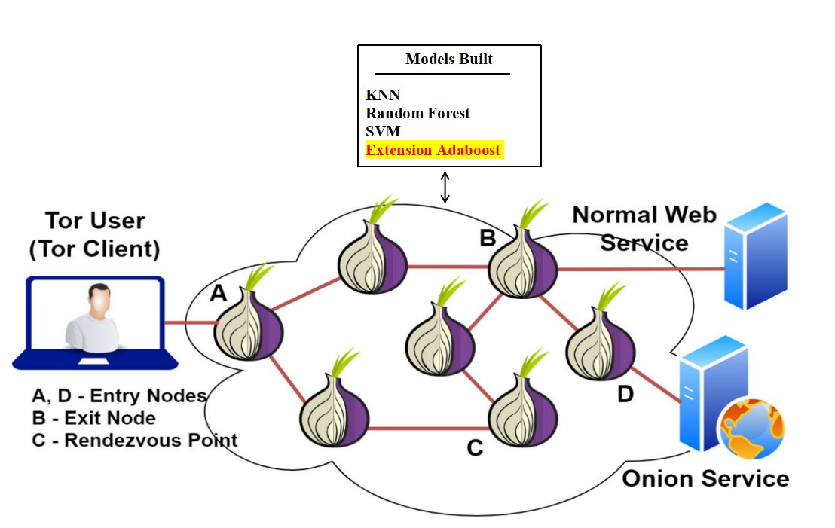
Fig.5.1.1 System architecture
DATA FLOW DIAGRAM:
The DFD is sometimes known as a bubble chart. This straightforward visual formalism for depicting a system consists of three primary parts: data input, data processing, and data output.
Data flow diagrams (DFDs) are crucial to the modelling process. To model the parts of the system is the point of employing it. Everything that the system performs, any data it consumes, any third parties it communicates with, and any information that flows through it is included by this.
Lastly, DFD reveals the data's evolution as it traverses the system. The changes that take place when data goes from an input to an output may be visually represented in a data flow diagram.
Bubble charts are sometimes known as data flow diagrams (DFDs). Any degree of abstraction may be shown in dynamic functional diagrams (DFDs). The complexity of its functions and the amount of data passing through them are two ways to classify DFD.

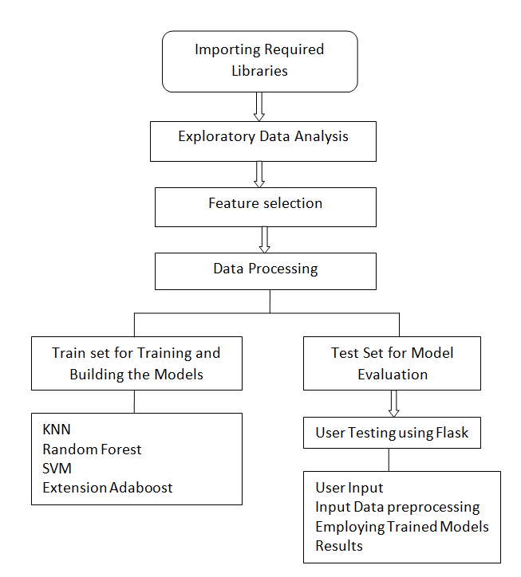
5.2 UML DIAGRAMS
The abbreviation UML, which stands for the Unified Modelling Language, is very useful. The Universal Modelling Language, or "UML" for short, is one rule for software engineering that centres on objects. The Object Management Group is in charge of supervising and developing the standard.

The Unified Design Language's (UDL) primary objective is to provide a standard language for developing object-oriented software systems. Using its syntax and meta-model, modern UML is quite dependent. It is possible to include more procedures or methods into UML in the future. Any kind of artefact, from software systems to non-software systems to business models, may be more easily specified, visualised, produced, and recorded with the help of the Unified Modelling Language.
Large and complicated systems may be represented using the Unified Modelling Language (UML), which offers a foundation for engineering best practices. Unified Modelling Language (UML) is a crucial component of creating object-oriented software or any application. When it comes to designing software projects, the Unified Modelling Language (UML) is primarily dependent on visual notations.
The original intent of the Unified Modelling Language (UML) was to accomplish the following:
1. Enable the development and sharing of practical models by providing a visual modelling language that is both expressive and easy to use.
2. Provide tools for customisation and expansion to enhance the adaptability of the main principles.
3. Don't be closed off to other ways of thinking and doing things when it comes to growth, no matter what language you use.
4. Developing a strong formal foundation is the fourth stage in becoming a master modeller.
5. Require that a larger number of individuals acquire OO tools.
6. Provide backing for developer-level ideas including frameworks, components, partnerships, and patterns.
7. Follow the standards set by the industry.

Among the many UML behavioural diagrams, the use case study is responsible for creating use case diagrams. You might think of it as a visual representation of the relationships between the many use cases, the people using the system, and the goals they are trying to achieve. A use case diagram may assist break down a complex system into its component elements and the tasks they carry out. It is feasible to demonstrate the operation of the system's different components.
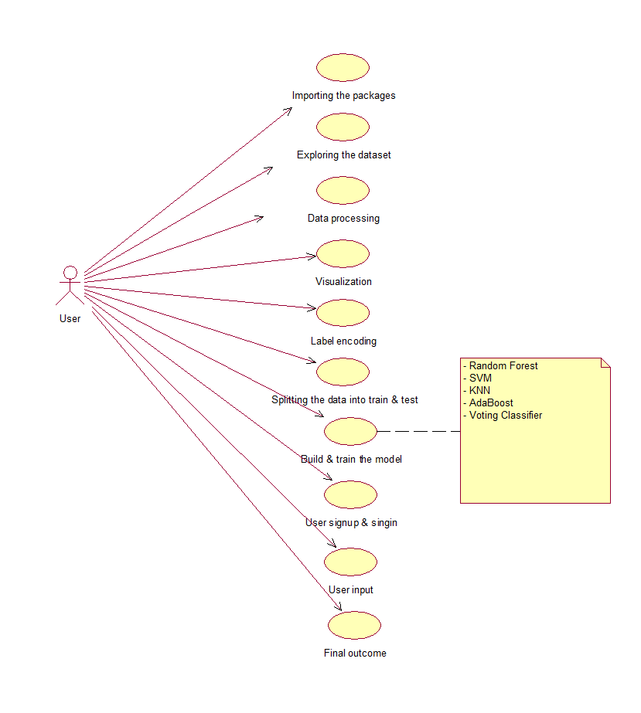
Class diagram:
It is possible to improve the use case diagram and provide a more detailed specification of the system's architecture by using the class diagram. The use case diagram specifies a group of actors and the class diagram details the connections between them. Your classes may use either a "is-a" or a "has-a" connection. It is possible that the classes shown in the class diagram may perform certain tasks. Classes accomplish their goals in part by means of the "methods" they provide. This aside, it's possible that distinct classes use different sets of "attributes" to distinguish themselves apart from one another.
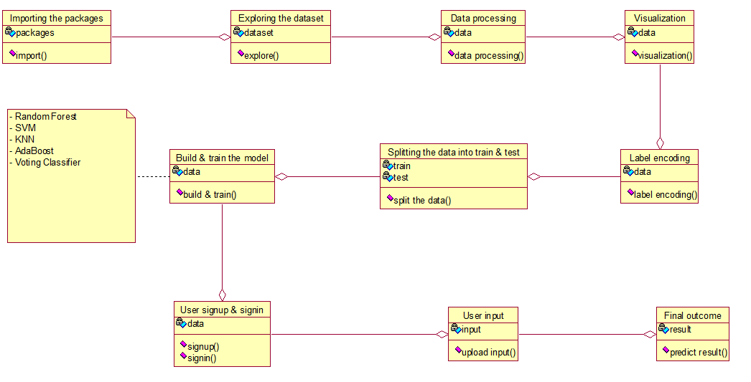
Activity diagram:
The activity diagram depicts the system's process flows. An activity diagram is quite similar to a state diagram in that it also shows guard conditions, starting and ending states, tasks, and activities as well as transitions between them.
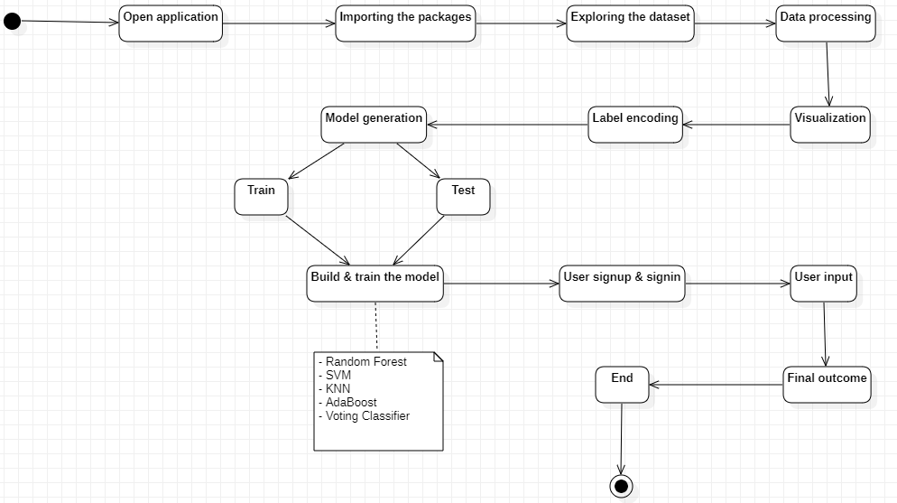

Sequence diagram:
Draw a sequence diagram to show the interdependencies between the system's components. One distinguishing feature of a sequence diagram is the temporal ordering of occurrences. Because of this, interactions between objects may be shown in great detail and in a sequential fashion. The different components in the sequence diagram are able to interact with one another via the "messages" they use.

Collaboration diagram:
The relationships between many things may be shown in a cooperation diagram. The order of the interactions may be seen by looking at the numbered list of interactions. Every conceivable interaction between components may be shown in the cooperation diagram.
Component diagram:
The system's essential components are shown in the component diagram. This schematic provides an overview of the system by showing its primary parts and their interconnections. To better understand how a built or created system works, a component diagram may be very helpful. 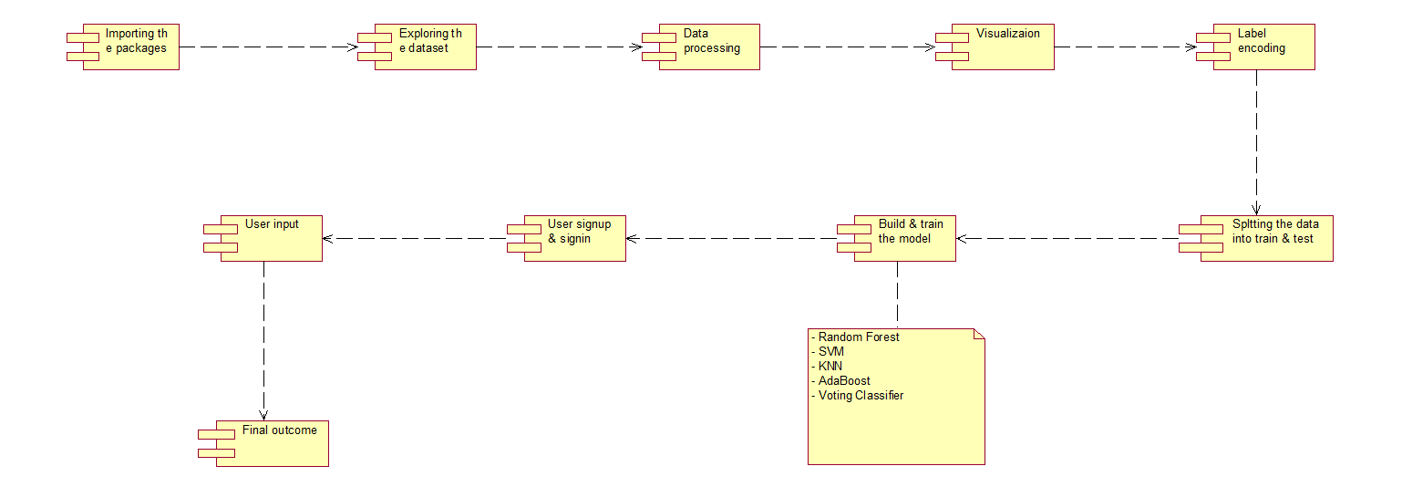

Deployment diagram:
In the deployment diagram, you can see how the application's runtime components are configured. This graphic becomes very useful when a system is ready for deployment.
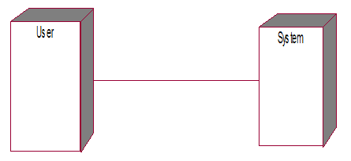

6.IMPLEMENTATION
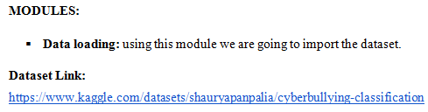
Dataset Description:
The data in this collection is based on suspicious activities, such as cyber bullying that uses racial and ethnic profiling extensively and makes threats and uses harsh language. The information was sourced via Twitter and Face book groups. Data is categorised according to the presence or absence of potentially problematic language in tweets and comments. After data scraping, manually assign a questionable data value of -1 and a non-doubtful data value of 0.
We will be using this module to get the data ready for analysis.
This module allows us to create a 'train set' and a 'test set' from the information we have.
The process is called model making. Naïve Bayes and logistic regression are used. The Idea of Bayes Probability and Fuzzy GA An amalgamation of LR fuzzy GA, RF, AB, and stacking classifiers into a single voting classifier. Accuracy of algorithms' predictions
This module will be used to gather the login and registration information of users.
The users supplied data: To gather information for forecasts, you may use this module.
The projected final outcome is shown.
Using an ensemble approach to combine the predictions of many models led to a more accurate and reliable final forecast.
Improvements in performance, maybe as high as 99% accuracy, are possible with the addition of two additional ensemble methods: Voting Classifier and Stacking Classifier.
Formulas for calculations [F]
One method of classification that relies on Bayes' Theorem is Naive Bayes, which assumes that predictors are independent. A Naive Bayes classifier, in its most basic form, takes for granted that there is no correlation between two features that share a class.
To solve binary classification issues, logistic regression determines the likelihood of a result, occurrence, or observation. It falls within the category of supervised machine learning. The model can only provide a yes/no, 0/1, or true/false result.
The Naive Bayes algorithm is among the most well-known and user-friendly approaches to machine learning classification, alongside Naive Bayes Fuzzy GA. One may calculate probabilities and conditional probabilities using Bayes' Theorem.
One definition of a fuzzy genetic algorithm is an algorithm that uses fuzzy logic techniques to build some of its components. The algorithm is thereafter described as a sequence of commands.
Because they lack both volume and mass, particles serve as the basic unit of measurement in the PSO algorithm. One such example is Naive Bayes Fuzzy PSO. The trajectories of particles are fine-tuned by constantly changing their velocities in response to their own and other particles' flight experiences within the search space.
An ML model called the Voting Classifier (AB + RF) accepts a number of models as input and returns the class that has the best chance of being selected.
One ensemble approach to machine learning is stacking classifiers, which looks for methods to integrate the predictions of many successful ML models. Many Python programmers prefer to use the scikit-learn package when they need to build stacking ensembles.

7. SOFTWARE ENVIRONMENT
What is Anaconda for Python?

The Anaconda tool makes it easy to build up an environment that is compatible with multiple versions of Python and its packages. With Anaconda, you can manage your project environments and install, delete, and update packages to the latest versions. In addition, Anaconda makes it easy to launch any project with a single click. This makes it an ideal choice for those who are new to Python and are just starting out.

With that context in mind, we will next look at the installation of Anaconda Python.

How to install Anaconda for Python?

Simply download the installer for your operating system from the Anaconda Documentation website and follow the on-screen instructions to get Anaconda up and running. Simply double-click the installer file to begin the installation process when it has finished downloading.
Acceptance of the terms and conditions may be accomplished by following the on-screen instructions. If asked to "add Anaconda to my PATH environment variable," just choose "yes." Doing so will enable you to include Anaconda in the PATH, a path that your OS uses to locate files.
The installation will end with an option to "Enable Anaconda as my default Python." shown. Select "yes" if you would want to use Anaconda as your default Python interpreter.
Anaconda Installation with Python
Installing Python Anaconda is the next step in the course. The latest version of Anaconda that is currently available is 2019.10. To get Anaconda installed on your computer, follow these steps:
To get Anaconda for Mac, Windows, or Linux, use this URL: - An Get the Anaconda archive.

The installers for Python 3.7 and Python 2.7 are both available for download at the moment. Not to mention that it's free for both 32-bit and 64-bit laptops.
Step 2: Run the application you downloaded by double-clicking the.exe file. Here is how Anaconda is set up. Moving on, press the button.
Step 3: The licence agreement will now be shown. Tap the "I Agree" button.
4. You have the option to install it for your own use or for all users. You will need administrative rights to install it for every user.
5. Go ahead and choose the installation location. The amount of space you require and the amount that is available are both shown here.
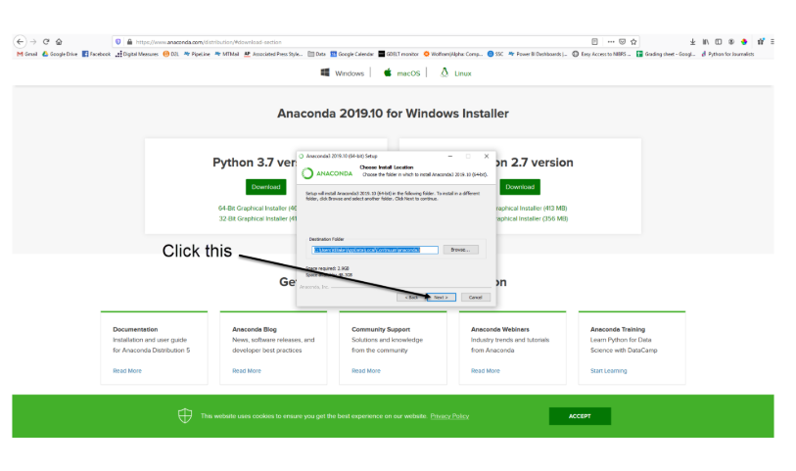

6. Several advanced choices will be presented to you now. Adding Anaconda to the PATH environment variable will make it the main executable for Python 3.7. If you include it in the PATH, it will be available before other installations. Select "Install" from the menu.
7. it will unpack some packages and extract some files on your machine. This will take a few minutes.
8. The installation is complete. Click Next.
9.This screen will inform you about PyCharm.Click Next
10. The installation is complete. You can choose to get more information about Anaconda cloud and how to get started with Anaconda. Click Finish
11. If you Search for Anaconda now, you will see the following options:
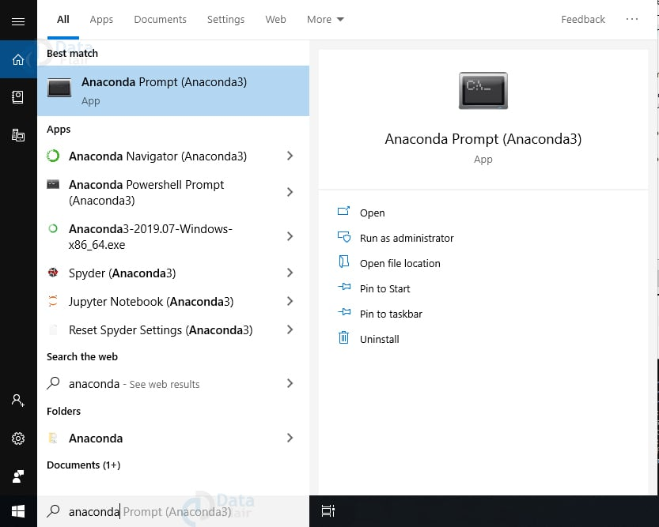
PYTHON LANGUAGE:
The dynamic semantics of Python make it an object-oriented language suitable for use at the interpreter level. Because of the binding, dynamic typing, and high-level built-in data structures, component glueing, and app building are made easy. Since Python has a simple and inexpensive syntax, it makes programs easier to administer. Because of its excellent modules and packages, Python greatly promotes code reuse and application modularity. Both the Python interpreter and the standard library are available for usage on all major platforms for free and are open source. Because it allows them to work faster, programmers adore Python. Because compilation is unnecessary, this round of testing, changing, and debugging is lightning quick. Since segmentation faults aren't caused by bugs or incorrect input, debugging Python programs is a snap. The interpreter will instead throw an exception if it finds a mistake. Stack traces are shown when an exception occurs in the program that the interpreter is unable to handle. It is possible to create breakpoints, inspect variables locally and globally, explore lines of code, and evaluate expressions using a source level debugger. The reflective characteristics of Python, the language used to build the debugger, are clearly visible. However, the fastest approach to debug the program is often to add print statements to the code. Using this straightforward method is helpful since it just requires a few rounds of editing, testing, and fixing problems.
Python has gained notoriety as an open-source, high-level, dynamic interpreted language. Both procedural and object-oriented programming are supported. Because of dynamic typing, Python does not need variables to be defined with a specific type. Take this scenario into account: x= 10. The possible values of x could range from anything between a String and an into to something entirely else.
Machine-Assisted Modelling and Learning:
We will go into the details of a few approaches after defining machine learning and talking about its limits. Machine learning is not an area of artificial intelligence, despite popular belief to the contrary. This is the original intent of ML, but when used to data science; it really shines when seen as a tool for building models of data.
Machine learning is based on the idea of creating mathematical models that can analyse data. We introduce the idea of "learning" into these models by allowing the user to tweak certain parameters, which in turn allows the computer to "learn" from the data. After being trained with historical data, these models may be used to assess and forecast future data. For kicks, I'll give you, the readers; the task of determining how much this "learning" based on mathematical models matches the "learning" shown by the human brain. It is critical to comprehend the problem context in machine learning in order to use these techniques effectively. For that reason, we will start by classifying the methods that will be covered into several general groups.
A number of subfields fall under the umbrella of machine learning, such as:
The two main branches of machine learning are supervised and unsupervised learning.
In supervised learning, unlabelled data is labelled by simulating the relationship between a label and measurable data points. The labels used in classification problems are discrete categories, but the variables used in regression tasks are continuous. This leads to an even more split in duties. Both types of supervised learning will be discussed and shown in this section.
Unsupervised learning is sometimes referred to as "letting the dataset speak for itself." Modelling the properties of a label-less dataset is the goal of this technique. Among the many things that these models can do are clustering and dimensionality reduction. Data representations may be made simpler via the use of dimensionality reduction technologies. Data is grouped into several categories using clustering algorithms. What follows is a section with examples of supervised and unsupervised learning.
Machine Learning and Its Significance
Humans are the most intelligent and technologically advanced species on Earth because we are superior to all other animals in the ability to analyse, evaluate, and solve issues. At the same time, artificial intelligence has a ways to go before it can match human intelligence. Machine learning's need is being legitimately questioned at this moment. That we should "make decisions, based on data, with efficiency and scale" is the strongest case for further action.
Companies are pouring money into new AI, ML, and DL systems because they promise to address problems in the real world and provide data-driven insights. This is an instance of data-driven machine decision-making, exemplifying process automation. It is possible that data-based judgements may replace programming logic when dealing with problems that cannot be completely written. Complex, real-world problems need intelligent people to find solutions. Machine learning's importance is highlighted by this.
Due to the lack of experienced professionals in machine learning (ML), which is still in its early stages, acquiring expert resources might be challenging. When it comes to identifying problems in businesses, ML also lacks a defined goal, which is a major drawback. The main reason for this is that ML has not yet fully matured and fulfilled its potential.
Over fitting or under fitting a model causes it to provide an inaccurate representation of the data.
Another issue that ML models face is the curse of dimensionality. It occurs when there are too many data points with properties. This may be a huge problem, and I feel the same way. The ML model is sophisticated, which makes practical implementation tough.
Deep learning, what is it?
Deep learning networks are a subset of machine learning that use three or more tiers of neural connections. Such neural networks "learn" from large datasets by making clumsy attempts to imitate the human brain's operations. Although neural networks may provide passable estimates with only one hidden layer, adding more layers has the potential to greatly improve accuracy.
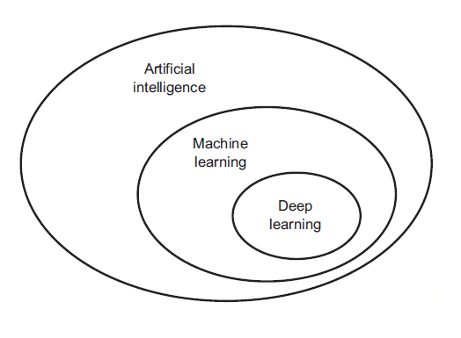
Using deep learning, a plethora of AI applications and services are able to automate hitherto human-only analytical and physical tasks. Any modern or ancient technology worth its salt needs deep learning technology. Digital assistants, voice-enabled TV remote controls, self-driving cars, and credit card fraud detection all depend on it.
An approach to deep learning
Deep learning neural networks, also called artificial neural networks, use data inputs, weights, and bias to simulate the brain's processes in an effort to mimic the human brain. Accurate data item identification, categorisation, and characterisation are made possible by these parts working together.
Predictions and classifications made by a deep neural network become more precise as more layers are added to it. The term "forward propagation" describes the process of passing computations over a network. In a deep neural network, the nodes that can be seen directly by the human eye are the input and output layers. While the input layer of a deep learning model processes incoming data, the output layer generates the model's ultimate prediction or classification.
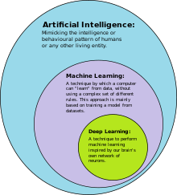
As an additional method for training models, back propagation iteratively traverses the layers in an attempt to determine the biases and weights of the function, after which it employs methods like gradient descent to identify prediction mistakes. By using back propagation and forward propagation, neural networks can both generate predictions and fix their own mistakes. As time goes by, the algorithm improves its accuracy.
The simplest form of a deep neural network is described here in a very basic way. While deep learning techniques might be complex, there are many different types of neural networks that can handle different types of challenges and datasets. One such example is the widespread usage of convolutional neural networks (CNNs) in computer vision and image classification. These networks are capable of recognising objects and other visually distinct characteristics in images. Due to its usage of sequential or time series data, recurrent neural networks (RNNs) are often used in voice recognition and natural language processing. In 2015, a CNN became the first computer to surpass a person on an item identification task.
LIBRARIES/PACAKGES:-
Tensor flow
The open-source Tensor Flow framework offers a dataflow and differentiable programming tool, which might be useful for many different types of applications. On top of that, it won't cost you a dime. Machine learning algorithms, such as neural networks, rely on symbolic mathematics. Both Google's research and manufacturing make use of it.
While developing Tensor Flow, the Google Brain team kept Google's core values in mind. It was made publicly available on November 9, 2015, using the Apache 2.0 license.
Oh, how innocent I was! Canine puppy
Numpy is an excellent tool to have on hand when dealing with arrays. The package includes a high-performance dimensional array object as well as utilities for manipulating arrays with many dimensions.
It is the core Python package for doing scientific computations. Among its notable features are a robust N-dimensional array object, facilities for integrating C/C++ and FORTRAN code, robust broadcasting capabilities, linear algebra expertise, random numbers, and the Fourier transform.
Numpy is a strong container for data in several dimensions, and its scientific applications are clear. Numpy is able to connect to several databases effortlessly because to its flexibility in defining data types.
Bearded dragons
Pandas is a free and open-source Python program that provides a comprehensive tool for dealing with and analysing data. The data structures it provides are robust. The primary functions of Python were data acquisition and pre-processing. In most cases, its usefulness for data analysis is restricted. Pandas were the ones that found it. No matter what kind of data you're working with, Pandas' five steps—loading, preparing, editing, modelling, and analysing—will always be the same. Numerous academic and professional fields make use of Python with Pandas. Statistics, economics, analytics, and finance are just a few examples of such areas.
For Matplotlib to function, it needs
Matplotlib is a 2D charting toolkit for Python that can generate publishable figures whether you're working with hardcopy forms or an interactive environment. In addition to Jupyter Notebook, four distinct GUI toolkits, and Python shell, the Matplotlib library is compatible with any version of Python. Matplotlib streamlines critical and straightforward tasks while making more complex ones easier. Graphs like bar charts, error charts, scatter plots, histograms, and power spectra may be easily generated with little code. Browse the galleries of sample graphs and thumbnails to see more examples.
Using the pilot module with IPython is ideal for basic charting jobs because to its MATLAB-like interface. Through an object-oriented interface or a method set known to MATLAB users, power users may alter any feature of the graph, including line styles, font quality, axis attributes, etc.
Use Scikit to learn more
With Scikit-learn, a consistent-interface Python package, you have access to a variety of supervised and unsupervised learning techniques. Academic and business groups find it appealing due to its interoperability with several versions of Linux and its liberal simplified BSD license.

8. SYSTEM TESTING
The quality assurance (QA) group investigates the interplay between an application's different parts in system testing, which is also called system-level testing or system-integration testing. System testing is all about making sure software works the way it's supposed to. This step, which is analogous to black box testing, examines the program's internals. For instance, it is standard practice in system testing to ensure that every user input elicits the desired response of the program.
Here are the components of each system testing step:
This level of the test has a video lecture. In system testing, the main goal is to ensure that all of an application's many parts work together without a hitch. System testing is the next step in quality assurance after functional or user-story testing and integration testing of each component.
After system testing, the last stage before a software build is sent to production—the area where actual users will be using it—is acceptance testing. In addition to keeping track of all issues, the app-dev team decides what constitutes an acceptable quantity and kind of problems.
The optimal course of action is to optimise the approach in order to improve software engineering testing (Software Testing Procedures 8.1). The goals, timeline, and methodology for testing software to guarantee it is up to par are outlined in a software testing plan. The following software testing approaches often accomplish this end goal:
Ensure All Static Is Valid:
Static testing does not include launching the product in development at this stage. At its most basic level, desk-checking is what is needed to find errors and flaws in the code. This kind of pre-deployment review is critical for preventing issues brought on by software design and code errors.
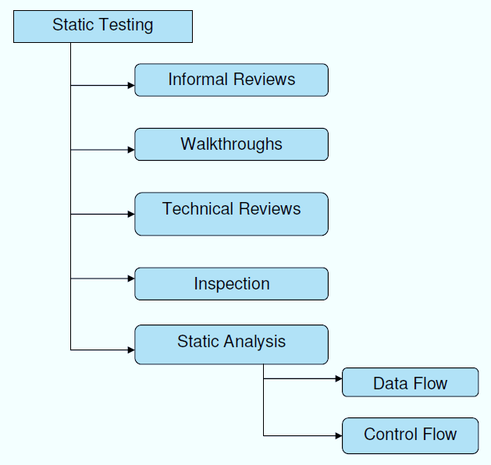
Structural Testing:
You can't evaluate the program thoroughly until you run it. In order to find and fix bugs and issues that crop up during the pre-production stage of software development, structural testing—also called white-box testing—is essential. This is the point where the program's structure decides whether regression testing is used for unit tests or not. Typically, this step of development is carried out automatically inside the test automation framework. By comparing test results from various versions, developers and QA engineers may monitor the system's behaviour. They are able to do this because they are privy to the software's internal workings and data flows throughout the testing phase.
Behavioural Testing:
Instead than focussing on the program's inner workings, this last phase of testing examines how it reacts to certain tasks. From the perspective of the end user, behavioural testing (also called black-box testing) involves subjecting the product to a battery of manual tests designed to reveal any issues that may arise. Quality assurance engineers, for example, often know a little bit about the business's or other software's intended use ('the black box') so they may react to problems and usability tests by acting like genuine users. Behavioural testers may use automation, particularly regression testing, to further ensure that no human mistake occurs across repeated tasks. An excellent method for evaluating a product's efficacy would be to automate the completion of one hundred online registration forms.
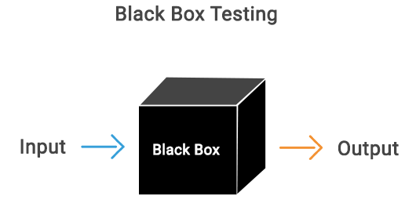

  - TEST CASES:
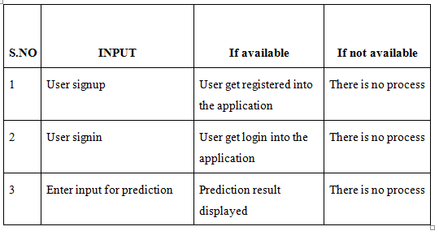
9.RESULTS AND DISCUSSION
In propose work we have trained SVM, KNN and Random Forest on Original TOR dataset, Modified WTFPAD dataset and OS Onion Services dataset. First algorithms get trained on Original TOR data, second time algorithm get trained on WTFPAD dataset and then for third time we combine OS and WTFPAD dataset to classify network as Tor or Onion. Each algorithm is tuned using Hyper parameters.
In propose work author has used traditional machine learning algorithms and have not used any advance machine learning algorithms like XGBOOST or ADABOOST so as extension we have experimented with ADABOOST algorithm which will use multiple estimator for training and then used estimator with best accuracy.
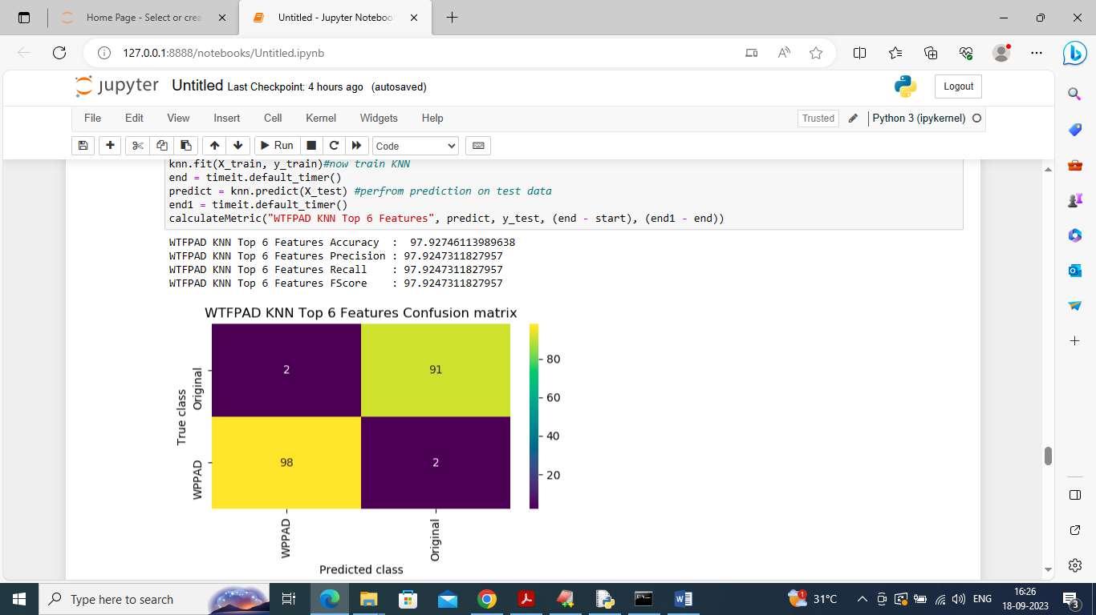
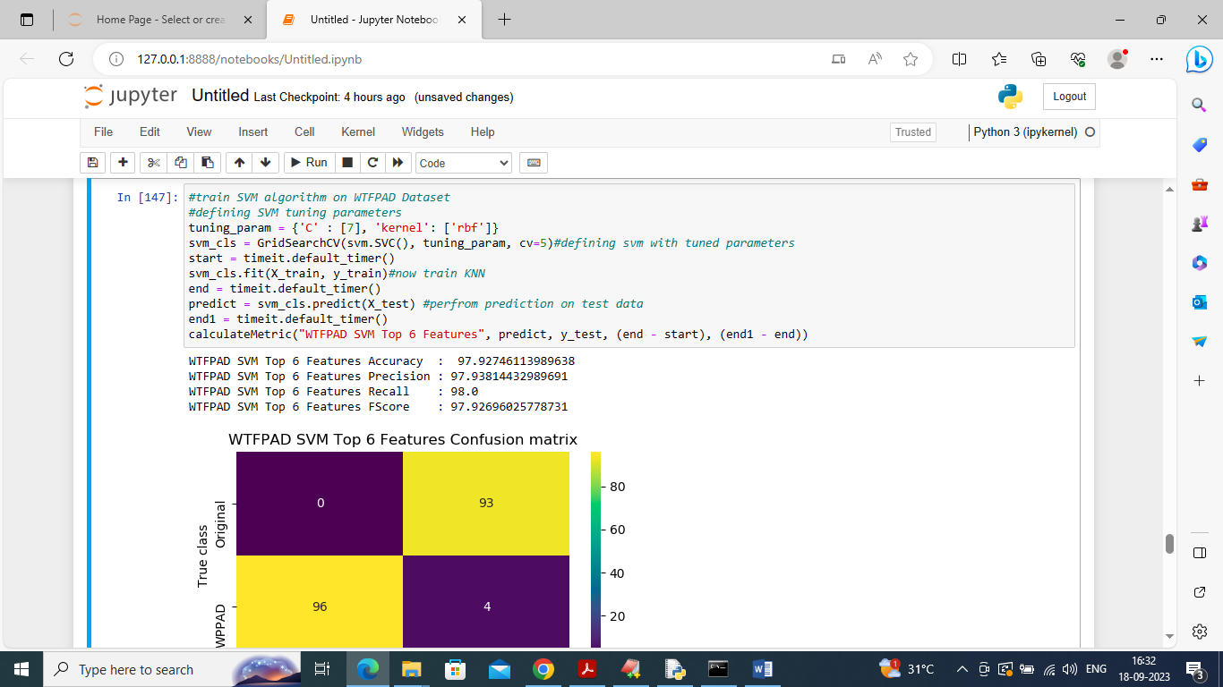
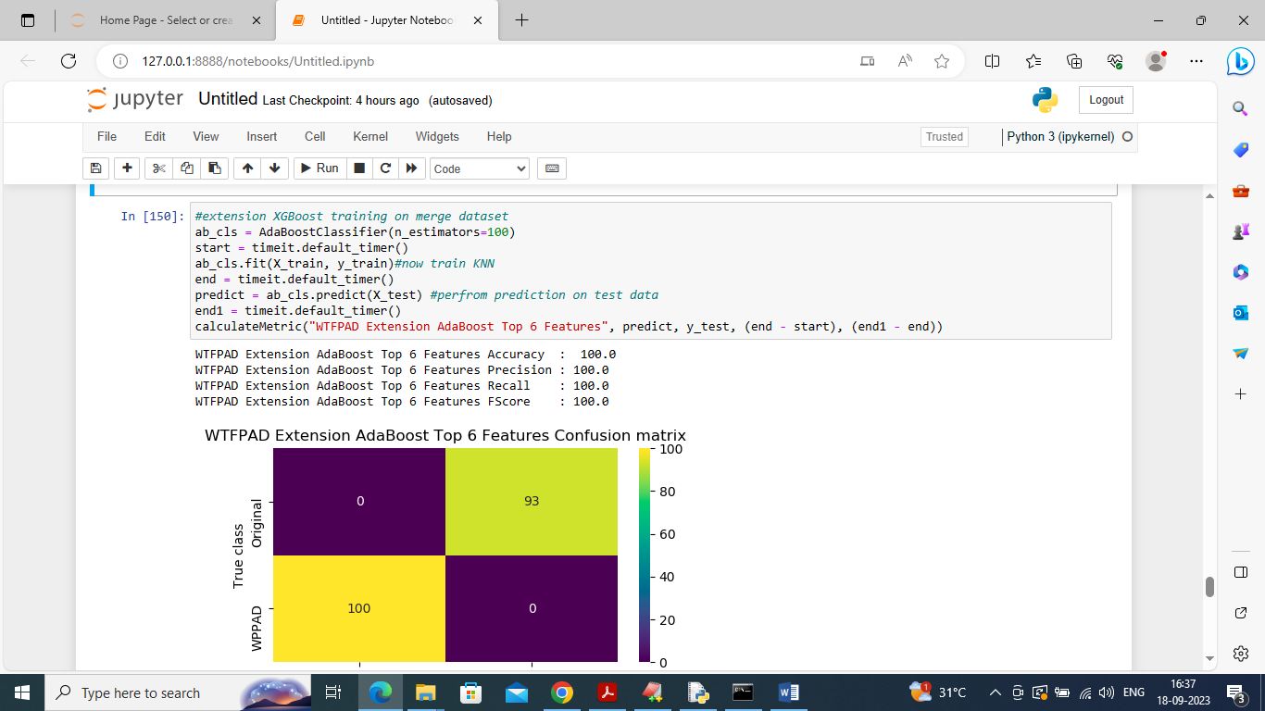
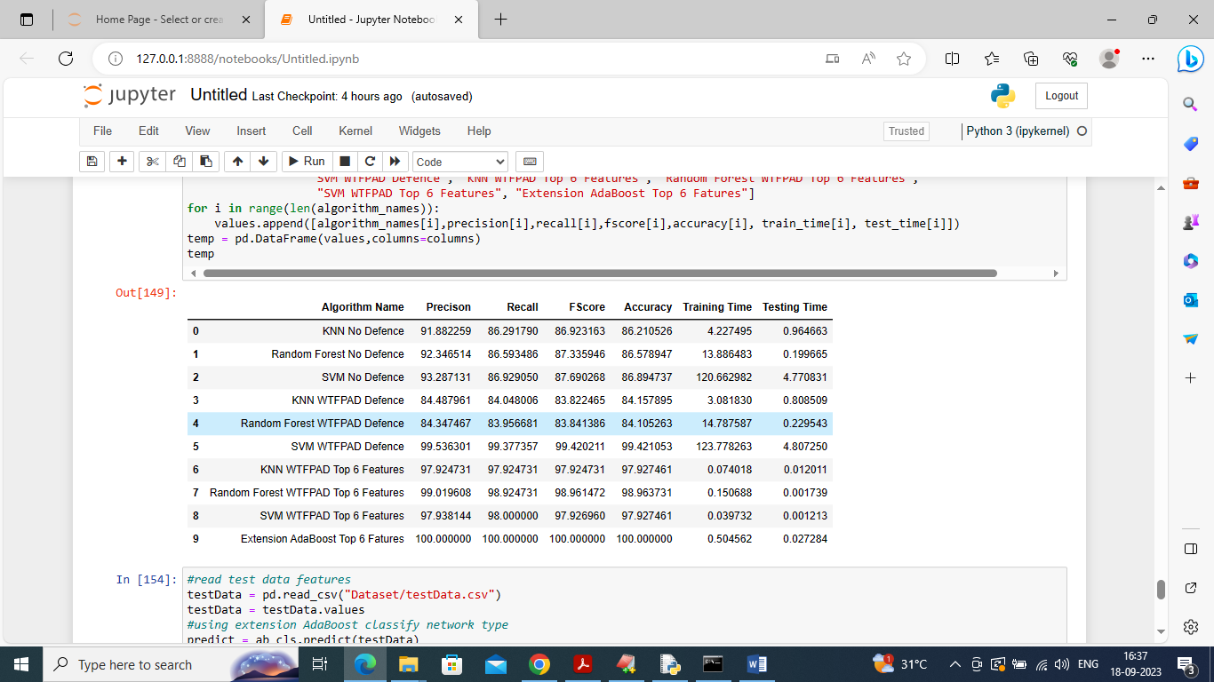
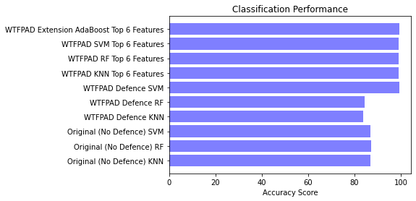
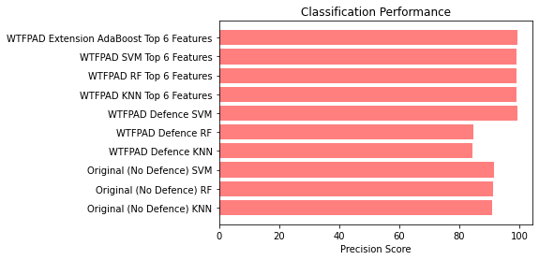
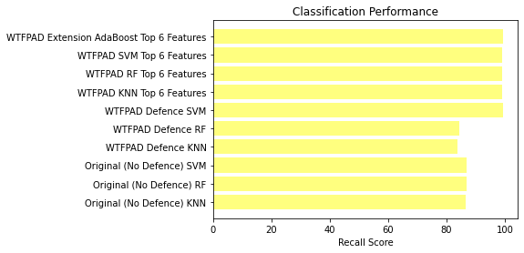
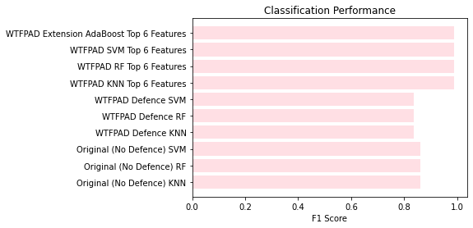

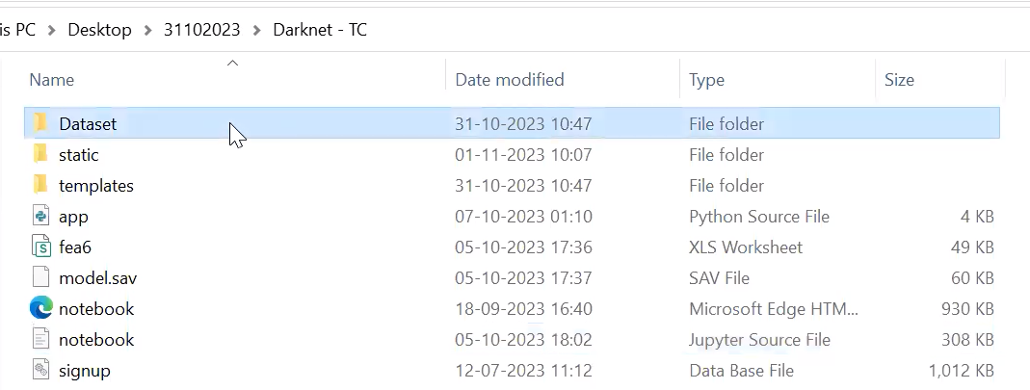
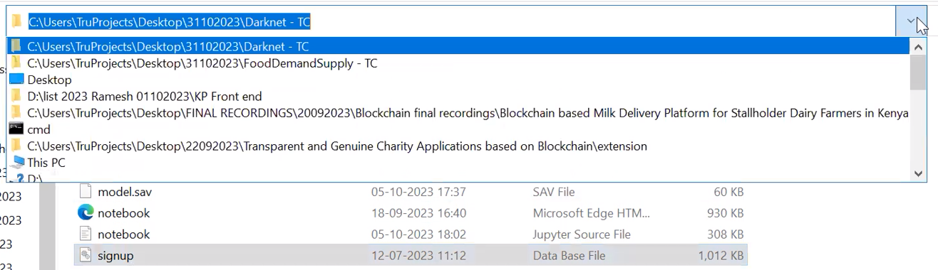
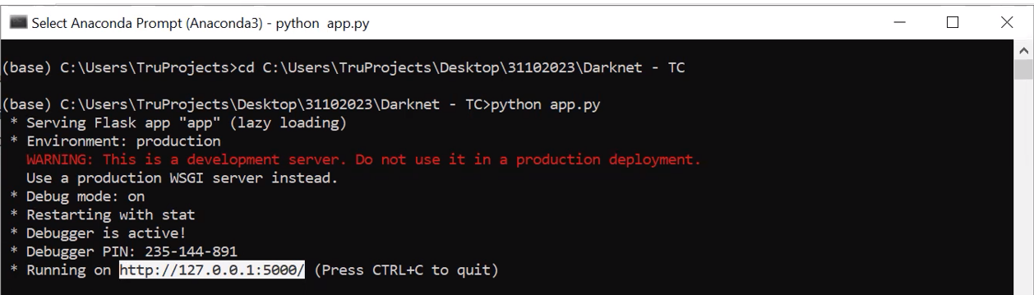
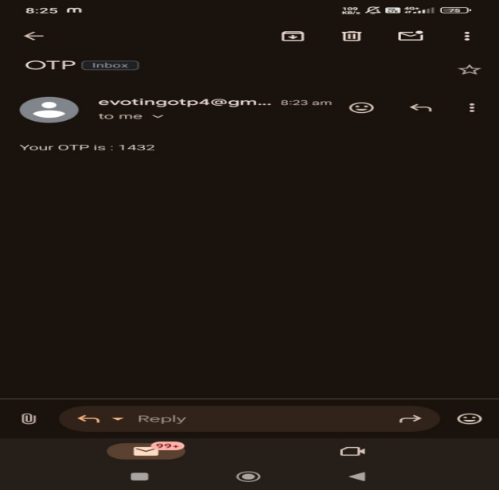
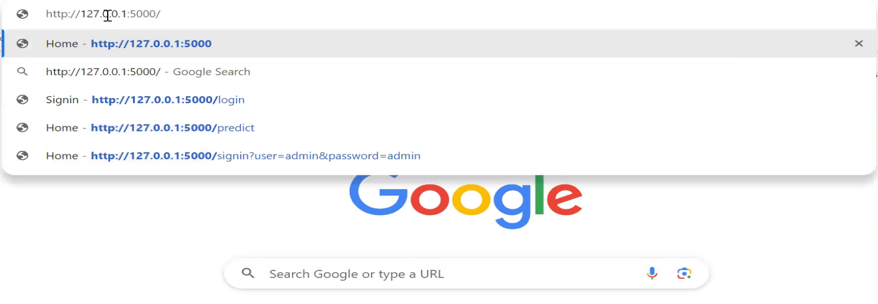
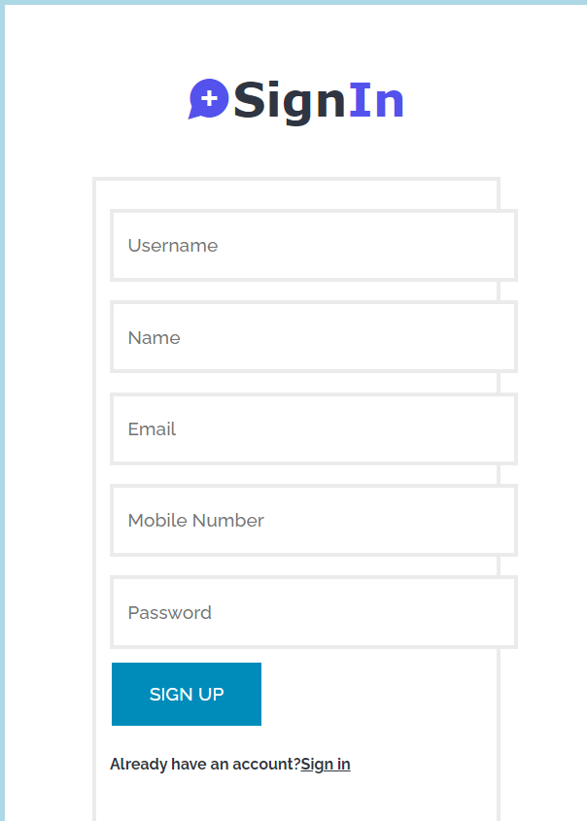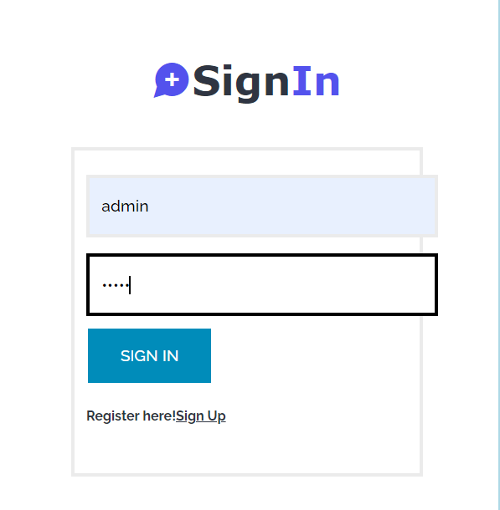

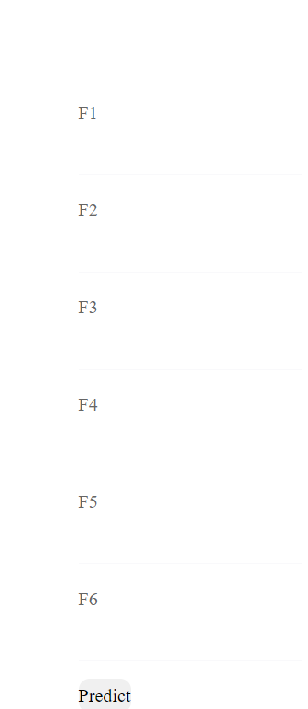

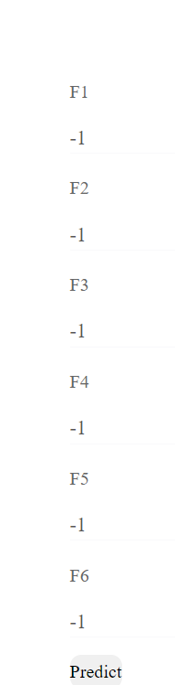

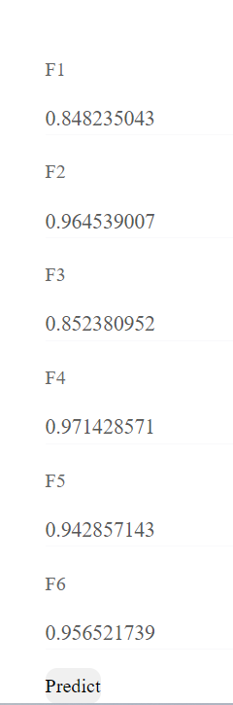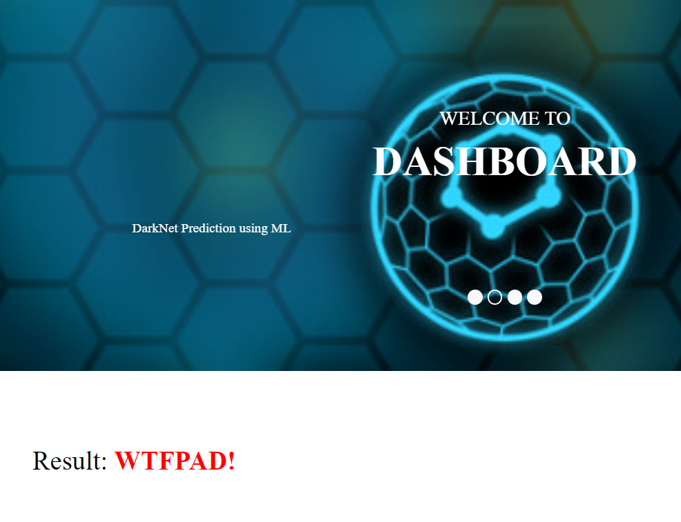

10. CONCLUSION
In this work, we answered three research questions focused on Onion Service traffic classification. We evaluated the ap plicability of supervised machine learning models to classify Onion Service traffic from other Tor traffic. We extracted f ifty features from each traffic trace and used that feature set as input to the machine learning classifiers. Our results showed that KNN, RF, and SVM classifiers have the ability to distinguish Onion Service traffic from Tor traffic with a 99% accuracy. Then, we tried to identify whether state-of-the-art Website Fingerprinting defences affect the classifiability of Tor traffic. These defences introduce different modifications to try and obfuscate information leakage from traffic, and we evaluated how those changes affect the Onion Service traffic classification. Our experiments showed that the above classifiers, combined with our feature set, reduce the perfor mance for Onion Service traffic classification. However, we observed that the modified Tor traffic is still distinguishable. Moreover, we used three feature selection metrics, namely, information gain, Pearson’s correlation, and Fisher Score, to identify the top features for this task. Those top features were able to provide >98% success for classifying Onion Service traffic from Tor traffic. However, they could not provide such good results when modified Tor traffic traces were used.


11. REFERENCES
REFERENCES
[1] R. Dingledine, N. Mathewson, and P. Syverson, “Tor: The Second Generation Onion Router,” in Proceedings of the 13th USENIX Security Symposium, SSYM’04, (San Diego, CA, USA), pp. 303–320, August 2004.
[2] M. AlSabah, K. Bauer, and I. Goldberg, “Enhancing Tor’s Performance Using Real-Time Traffic Classification,” in Proceedings of the 2012 ACM Conference on Computer and Communications Security, CCS ’12, (NewYork, NY, USA), pp. 73–84, October 2012.
[3] A. H. Lashkari., G. D. Gil., M. S. I. Mamun., and A. A. Ghorbani., “Characterization of Tor Traffic using Time based Features,” in Proceedings of the 3rd International Conference on Information Systems Security and Privacy, ICISSP 2017, (Porto, Portugal), pp. 253–262, February 2017.
[4] M. Kim and A. Anpalagan, “Tor Traffic Classification from Raw Packet Header using Convolutional Neural Network,” in 1st IEEE International Conference on Knowledge Innovation and Invention, ICKII 2018, (Jeju Island, South Korea), pp. 187–190, July 2018.
[5] G. He, M. Yang, J. Luo, and X. Gu, “Inferring Application Type Information from Tor Encrypted Traffic,” in Proceedings of the 2014 Second International Conference on Advanced Cloud and Big Data, CBD ’14, (NWWashington, DC, USA), pp. 220–227, November 2014.
[6] A. Montieri, D. Ciuonzo, G. Aceto, and A. Pescape, “Anonymity Services Tor, I2P, JonDonym: Classifying in the Dark (Web),” IEEE Transactions on Dependable and Secure Computing, vol. 17, pp. 662–675, May 2020.
[7] “WCry Ransomware Analysis.” https://www.secureworks.com/research/wcry-ransomware analysis, May 2017. Accessed: 2023-04-26 [Online].
[8] “Keeping a Hidden Identity: Mirai C&Cs in Tor Network.” https://blog.trendmicro.com/trendlabs-security-intelligence/keeping a-hidden-identity-mirai-ccs in-tor-network/, July 2019. Accessed: 2023-04-26 [Online].
[9] “Global action against dark markets on Tor network.” https://www.europol.europa.eu/newsroom/news/global-action-againstdark-markets-tor-network, November 2014. [Online].
[10] M. Juarez, M. Imani, M. Perry, C. Diaz, and M. Wright, “Toward an Efficient Website Fingerprinting Defense,” in Proceedings of the 21st European Symposiumon Research in Computer Security, ESORICS2016, (Heraklion, Greece), pp. 27–46, September 2016.
[11] T. Wang and I. Goldberg, “Walkie-Talkie: An Efficient Defense against Passive Website Fingerprinting Attacks,” in Proceedings of the 26th USENIX Security Symposium, SEC’17, (Vancouver, BC, Canada), pp. 1375–1390, August 2017.
[12] W. De la Cadena, A. Mitseva, J. Hiller, J. Pennekamp, S. Reuter, J. Filter, T. Engel, K. Wehrle, and A. Panchenko, “TrafficSliver: Fighting Website Fingerprinting Attacks with Traffic Splitting,” in Proceedings of the 2020 ACM SIGSAC Conference on Computer and Communications Security, CCS’20, (New York, NY, USA), pp. 1971–1985, November 2020.
[13] J. Hayes and G. Danezis, “K-Fingerprinting: A Robust Scalable Website Fingerprinting Technique,” in Proceedings of the 25th USENIX Conference on Security Symposium, SEC’16, (Austin, TX, USA), pp. 11871203, August 2016.
[14] X. Bai, Y. Zhang, and X. Niu, “Traffic identification of tor and web-mix,” in Proceedings of the 2008 Eighth International Conference on Intelligent Systems Design and Applications- Volume 01, ISDA ’08, (Kaohsiung, Taiwan), pp. 548–551, November 2008.
[15] O. Berthold, H. Federrath, and S. Köpsell, “Web MIXes: A System for Anonymous and Unobservable Internet Access,” in Designing Privacy Enhancing Technologies, International Workshop on Design Issues in Anonymity and Unobservability (H. Federrath, ed.), vol. 2009 of Lecture Notes in Computer Science, (Berkeley, CA, USA), pp. 115–129, July 2000.

